Git - Tag and Release
# Source: AI Source: Provided by: [Data Path: Persons Table -> ID Column: 1, Name_En Column: Motasem Essam] -> From: [ChatGPT] on [2/19/2026]
A Git tag is a pointer to a specific commit, usually used to mark releases or important versions (v1.0, v2.1, etc.). Unlike branches, tags don’t move—they are fixed at a commit.
There are two main types of tags:
- Lightweight tags – simple pointers to a commit.
- Annotated tags – include metadata like tagger name, email, date, and a message.

1️⃣ List All Tags
# Source: AI Source: Provided by: [Data Path: Persons Table -> ID Column: 1, Name_En Column: Motasem Essam] -> From: [ChatGPT] on [2/19/2026]
- Syntax:
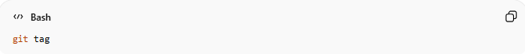
git tag
- Description: Lists all tags in the repository.
- Example:
git tag
Output:
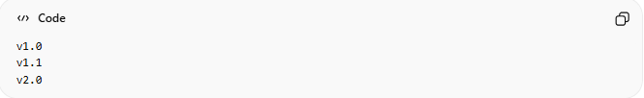
v1.0
v1.1
v2.0
Shows all existing tags.

2️⃣ Create a Lightweight Tag
# Source: AI Source: Provided by: [Data Path: Persons Table -> ID Column: 1, Name_En Column: Motasem Essam] -> From: [ChatGPT] on [2/19/2026]
- Syntax:
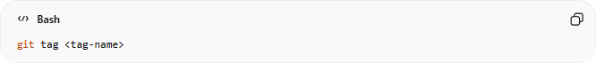
git tag <tag-name>
- Description: Creates a lightweight tag pointing to the current commit.
- Example:
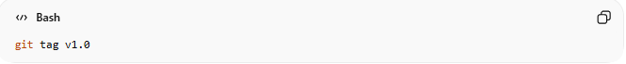
git tag v1.0
Creates a lightweight tag named v1.0 on the current commit.

3️⃣ Create an Annotated Tag
# Source: AI Source: Provided by: [Data Path: Persons Table -> ID Column: 1, Name_En Column: Motasem Essam] -> From: [ChatGPT] on [2/19/2026]
- Syntax:
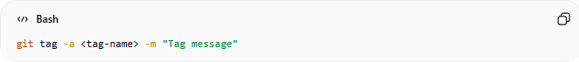
git tag -a <tag-name> -m "Tag message"
- Description: Creates a tag with metadata and a message. Preferred for releases.
- Example:
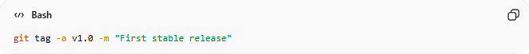
git tag -a v1.0 -m "First stable release"
Annotated tag v1.0 created with a message.

4️⃣ Tag a Specific Commit
# Source: AI Source: Provided by: [Data Path: Persons Table -> ID Column: 1, Name_En Column: Motasem Essam] -> From: [ChatGPT] on [2/19/2026]
- Syntax:
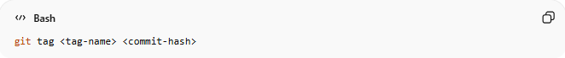
git tag <tag-name> <commit-hash>
- Description: Tags a commit other than the current one.
- Example:
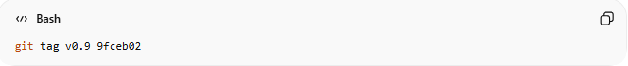
git tag v0.9 9fceb02
Tags commit 9fceb02 as v0.9.

5️⃣ Show Tag Details
# Source: AI Source: Provided by: [Data Path: Persons Table -> ID Column: 1, Name_En Column: Motasem Essam] -> From: [ChatGPT] on [2/19/2026]
- Syntax:
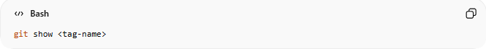
git show <tag-name>
- Description: Displays the commit info and message for the tag.
- Example:
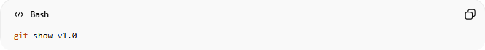
git show v1.0
Shows commit details for the v1.0 tag.

6️⃣ Push Tags to Remote
# Source: AI Source: Provided by: [Data Path: Persons Table -> ID Column: 1, Name_En Column: Motasem Essam] -> From: [ChatGPT] on [2/19/2026]
- Syntax:
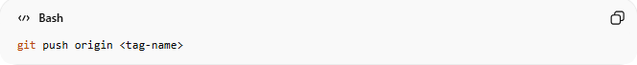
git push origin <tag-name>
Or push all tags:
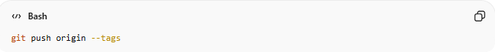
git push origin --tags
- Description: Sends your local tags to the remote repository.
- Example:
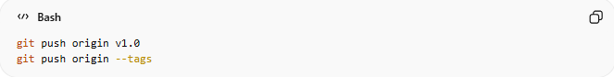
git push origin v1.0
git push origin --tags
Pushes the v1.0 tag (or all tags) to GitHub/GitLab.

7️⃣ Search a Tag

Method 1: Search Tags by Name (Pattern)
# Source: AI Source: Provided by: [Data Path: Persons Table -> ID Column: 1, Name_En Column: Motasem Essam] -> From: [ChatGPT] on [2/19/2026]
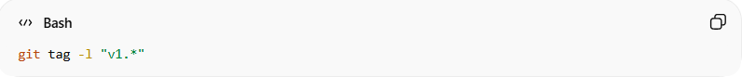
git tag -l "v1.*"
- -l → list tags matching a pattern
- "v1.*" → matches all tags starting with v1.
- Example:
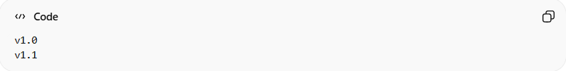
v1.0
v1.1

Method 2: Search Tags With grep
# Source: AI Source: Provided by: [Data Path: Persons Table -> ID Column: 1, Name_En Column: Motasem Essam] -> From: [ChatGPT] on [2/19/2026]
grep is a command-line tool used to search for text patterns inside files or input from other commands. Think of it as a filter that finds lines containing what you’re looking for.
It works on Linux, macOS, and Git Bash on Windows.

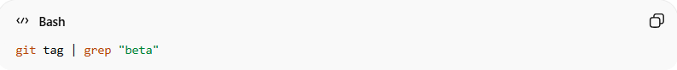
git tag | grep "beta"
- Pipes all tags to grep to find the ones containing "beta"
- Example:
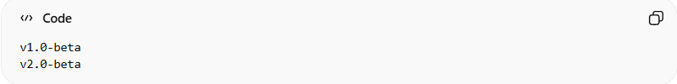
v1.0-beta
v2.0-beta

8️⃣ Delete a Tag
# Source: AI Source: Provided by: [Data Path: Persons Table -> ID Column: 1, Name_En Column: Motasem Essam] -> From: [ChatGPT] on [2/19/2026]
- Delete locally:
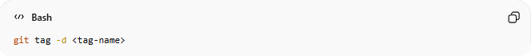
git tag -d <tag-name>
- Delete from remote:
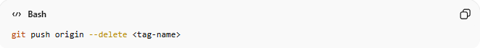
git push origin --delete <tag-name>
- Example:
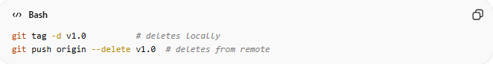
git tag -d v1.0 # deletes locally
git push origin --delete v1.0 # deletes from remote

💡 Tip:
- Tags are ideal for marking release points (v1.0, v2.0).
- Branches continue development; tags are snapshots.

🔁 How Tags and Releases Work Together
# Source: AI Source: Provided by: [Data Path: Persons Table -> ID Column: 1, Name_En Column: Motasem Essam] -> From: [ChatGPT] on [2/19/2026]
- You finish new features.
- You commit changes.
- You create a tag:
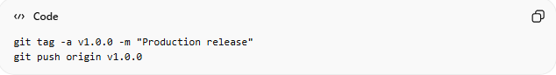
git tag -a v1.0.0 -m "Production release"
git push origin v1.0.0
- On GitHub/GitLab, you create a Release from that tag.
- Users can now download that exact version.

How create a Release from that tag On GitHub/GitLab
# Source: AI Source: Provided by: [Data Path: Persons Table -> ID Column: 1, Name_En Column: Motasem Essam] -> From: [ChatGPT] on [2/19/2026]
Here’s exactly how to create a Release from a tag on both GitHub and GitLab.

🚀 On GitHub
# Source: AI Source: Provided by: [Data Path: Persons Table -> ID Column: 1, Name_En Column: Motasem Essam] -> From: [ChatGPT] on [2/19/2026]
Step 1 — Push Your Tag (if you haven’t already)
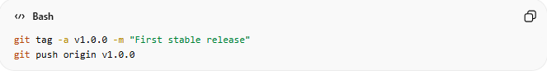
git tag -a v1.0.0 -m "First stable release"
git push origin v1.0.0

Step 2 — Create the Release in GitHub UI
- Go to your repository on GitHub.
- Click “Releases” (right side panel or under the repo menu).
- Click “Draft a new release”.
- Under “Choose a tag”:
  - Select your existing tag (v1.0.0)
  - Or type a new tag name (GitHub can create it for you)
- Fill in:
  - Release title (e.g., v1.0.0)
  - Description / Release notes
- (Optional) Upload built files (ZIP, binaries, etc.)
- Click “Publish release”
✅ Done. Your release is now public and downloadable.

🚀 On GitLab
# Source: AI Source: Provided by: [Data Path: Persons Table -> ID Column: 1, Name_En Column: Motasem Essam] -> From: [ChatGPT] on [2/19/2026]
Step 1 — Push Your Tag
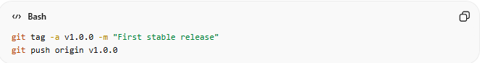
git tag -a v1.0.0 -m "First stable release"
git push origin v1.0.0

Step 2 — Create the Release in GitLab UI
- Go to your project in GitLab.
- Navigate to:
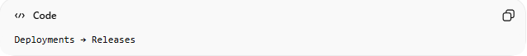
Deployments → Releases
- Click “New release”
- Select the existing tag (v1.0.0)
- Add:
  - Release title
  - Description
- Click “Create release”
✅ Finished.

🧠 Important Difference
# Source: AI Source: Provided by: [Data Path: Persons Table -> ID Column: 1, Name_En Column: Motasem Essam] -> From: [ChatGPT] on [2/19/2026]
- Git Tag = marks a specific commit
- Release = adds notes + downloadable files + visibility
A release always points to a tag.

🔥 Pro Tip (Automation)
# Source: AI Source: Provided by: [Data Path: Persons Table -> ID Column: 1, Name_En Column: Motasem Essam] -> From: [ChatGPT] on [2/19/2026]
Both platforms can:
- Auto-generate release notes
- Create releases automatically via CI/CD
- Create a release when a tag is pushed

Example

1️⃣ List All Tags
# Source: ScreenShots Source: Provided by: [Persons Table -> ID Column: 1, Name_En Column: Motasem Essam] -> Tool: [Lightshot Program] -> From [Operating System: Windows] on [2/19/2026]
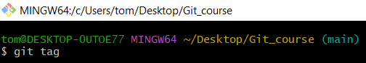
git tag

2️⃣ Create a Lightweight Tag
# Source: ScreenShots Source: Provided by: [Persons Table -> ID Column: 1, Name_En Column: Motasem Essam] -> Tool: [Lightshot Program] -> From [Operating System: Windows] on [2/19/2026]
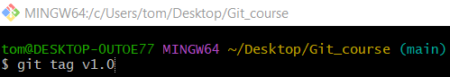
git tag v1.0
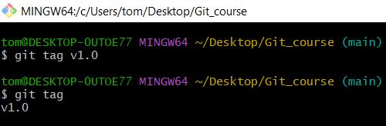

3️⃣ Create an Annotated Tag
# Source: ScreenShots Source: Provided by: [Persons Table -> ID Column: 1, Name_En Column: Motasem Essam] -> Tool: [Lightshot Program] -> From [Operating System: Windows] on [2/19/2026]
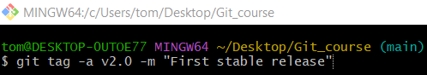
git tag -a v2.0 -m "First stable release"
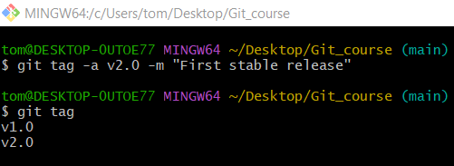

4️⃣ Tag a Specific Commit
# Source: ScreenShots Source: Provided by: [Persons Table -> ID Column: 1, Name_En Column: Motasem Essam] -> Tool: [Lightshot Program] -> From [Operating System: Windows] on [2/19/2026]
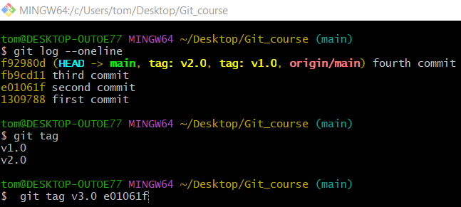
git tag v3.0 e01061f
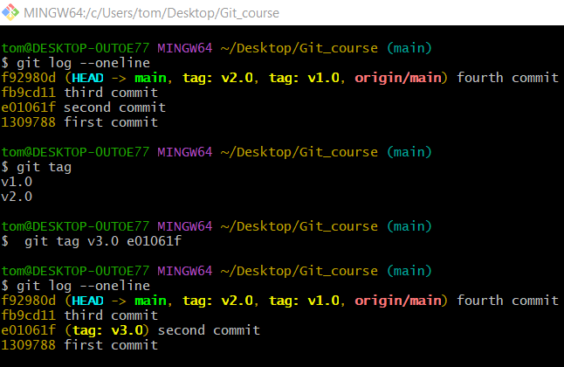

5️⃣ Show Tag Details
# Source: ScreenShots Source: Provided by: [Persons Table -> ID Column: 1, Name_En Column: Motasem Essam] -> Tool: [Lightshot Program] -> From [Operating System: Windows] on [2/19/2026]
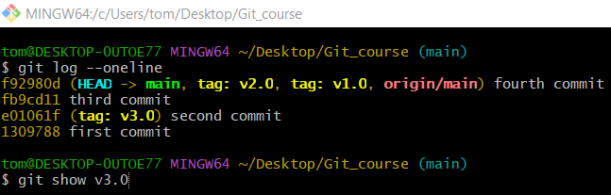
git show v3.0
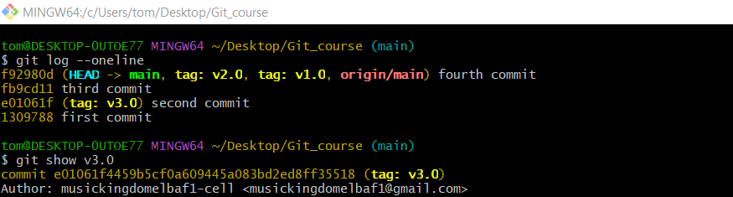
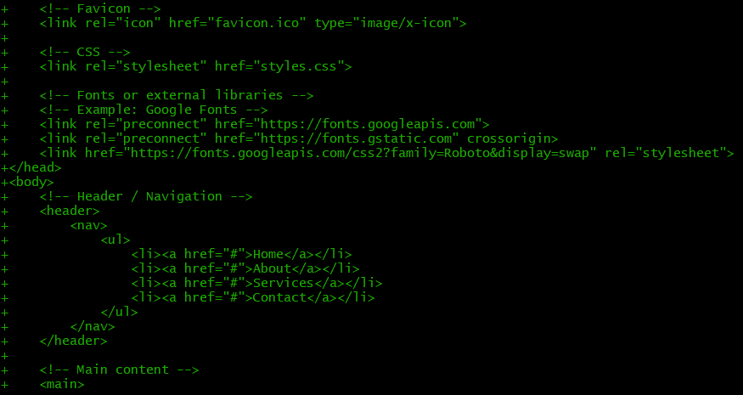

6️⃣ Push Tags to Remote

Specific tag
# Source: ScreenShots Source: Provided by: [Persons Table -> ID Column: 1, Name_En Column: Motasem Essam] -> Tool: [Lightshot Program] -> From [Operating System: Windows] on [2/19/2026]
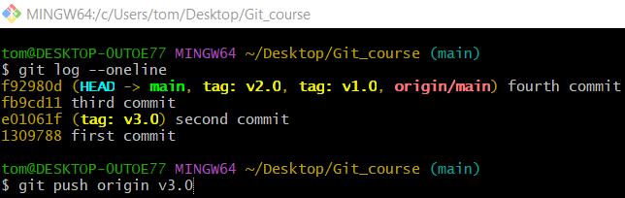
git push origin v3.0
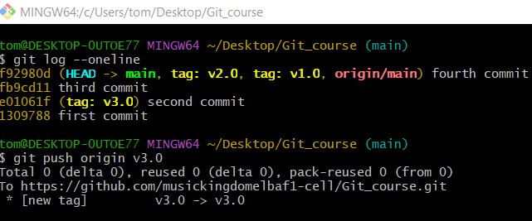

All tags
# Source: ScreenShots Source: Provided by: [Persons Table -> ID Column: 1, Name_En Column: Motasem Essam] -> Tool: [Lightshot Program] -> From [Operating System: Windows] on [2/19/2026]
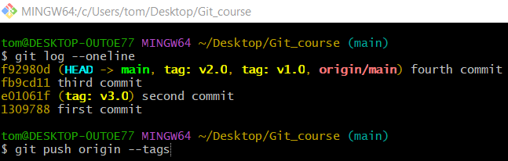
git push origin --tags
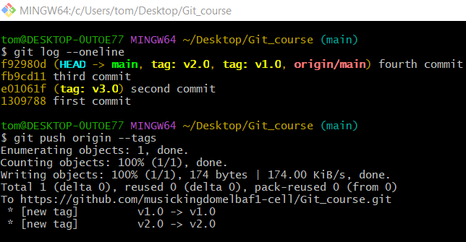

7️⃣ Search a Tag

Method 1: Search Tags by Name (Pattern)
# Source: ScreenShots Source: Provided by: [Persons Table -> ID Column: 1, Name_En Column: Motasem Essam] -> Tool: [Lightshot Program] -> From [Operating System: Windows] on [2/19/2026]
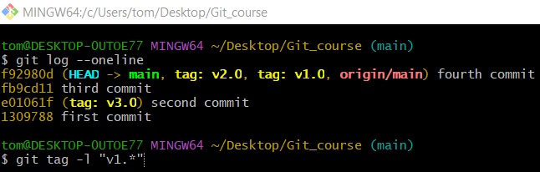
git tag -l "v1.*"
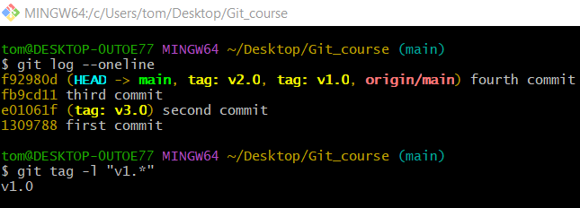

Method 2: Search Tags With grep
# Source: ScreenShots Source: Provided by: [Persons Table -> ID Column: 1, Name_En Column: Motasem Essam] -> Tool: [Lightshot Program] -> From [Operating System: Windows] on [2/19/2026]
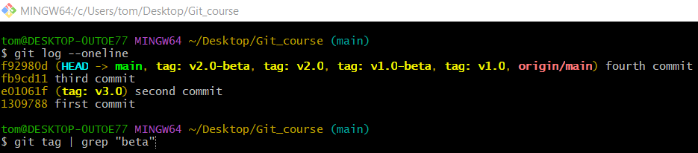
git tag | grep "beta"
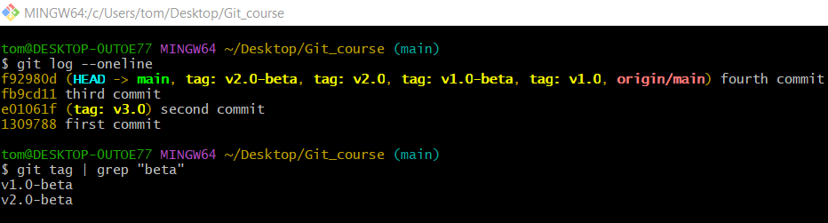

8️⃣ Delete a Tag
# Source: ScreenShots Source: Provided by: [Persons Table -> ID Column: 1, Name_En Column: Motasem Essam] -> Tool: [Lightshot Program] -> From [Operating System: Windows] on [2/19/2026]
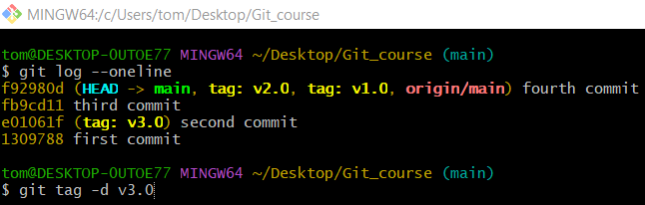
git tag -d v3.0
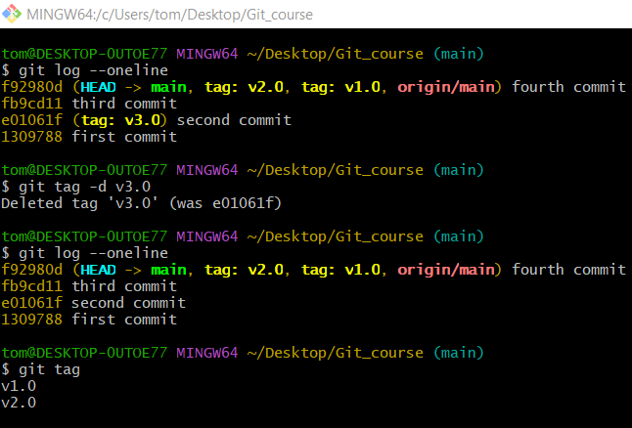

🔁 How Tags and Releases Work Together

🚀 On GitHub
# Source: ScreenShots Source: Provided by: [Persons Table -> ID Column: 1, Name_En Column: Motasem Essam] -> Tool: [Lightshot Program] -> From [Site: https://github.com] on [2/19/2026]
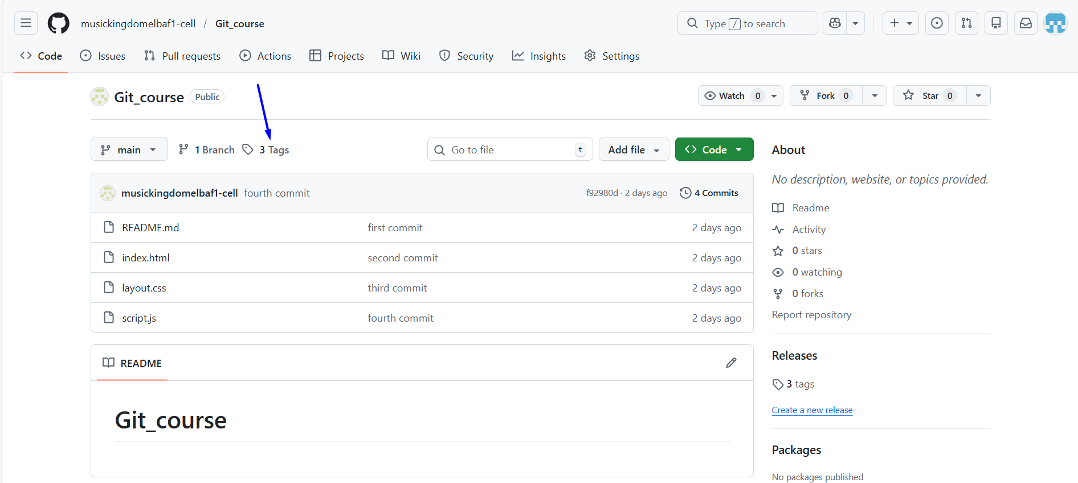
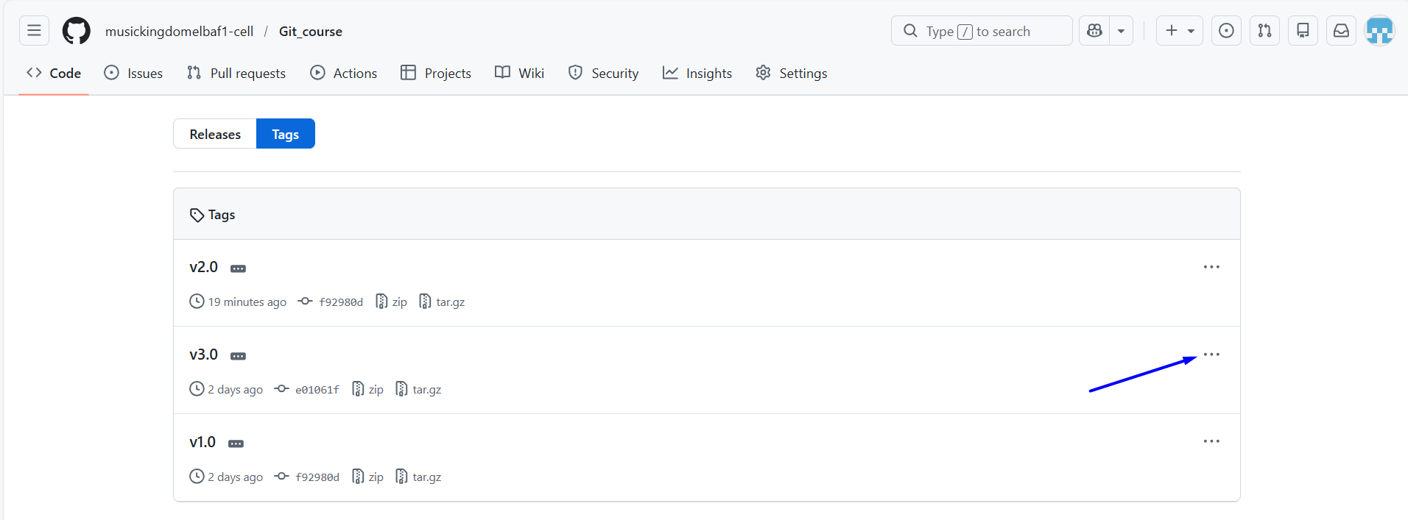
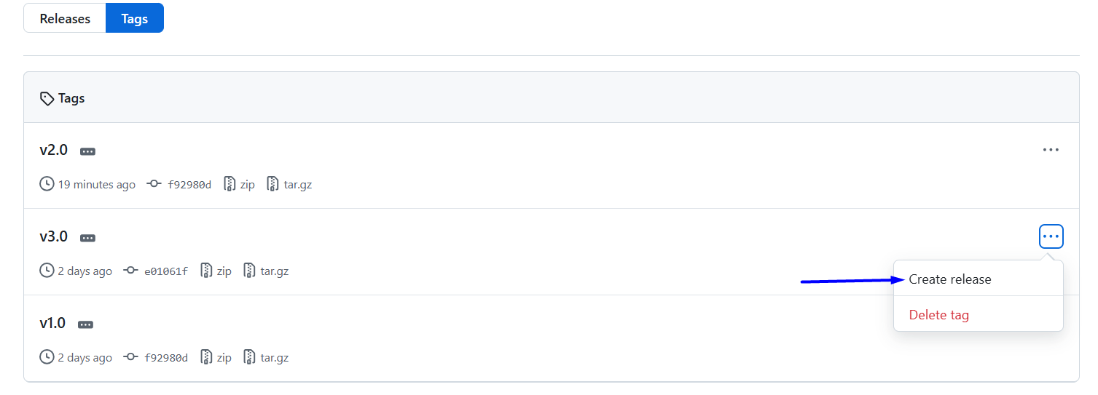
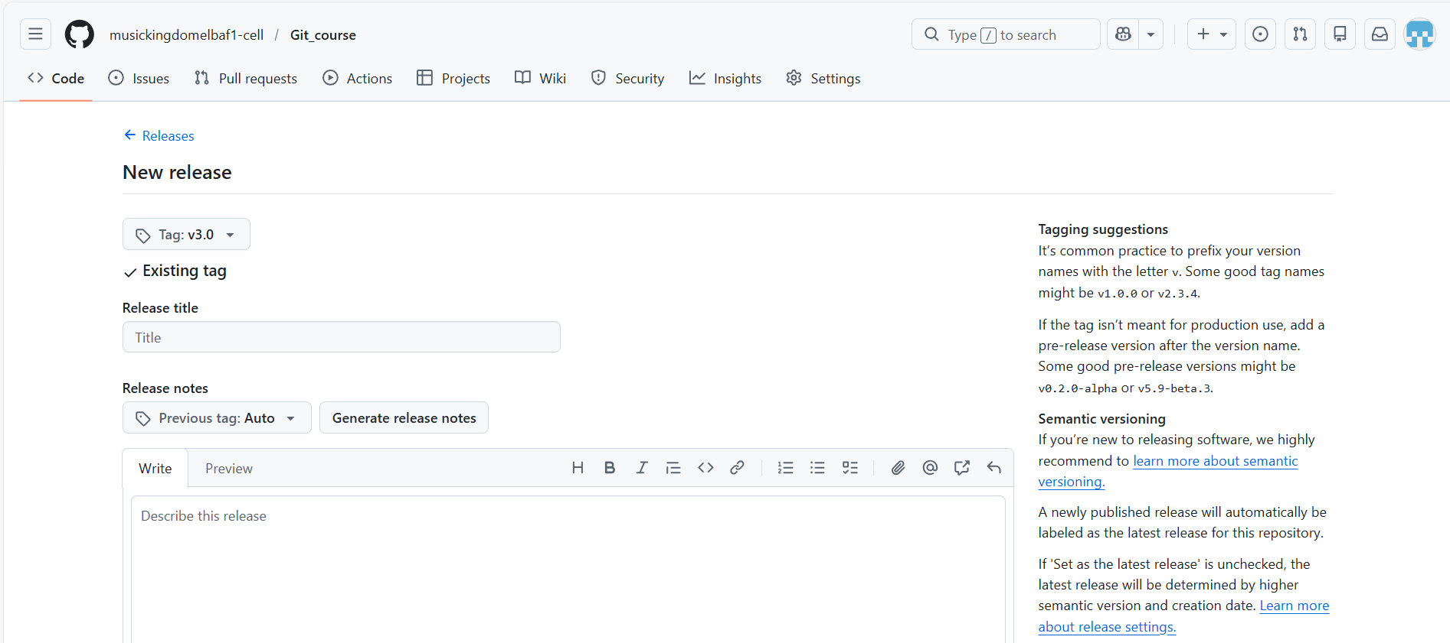
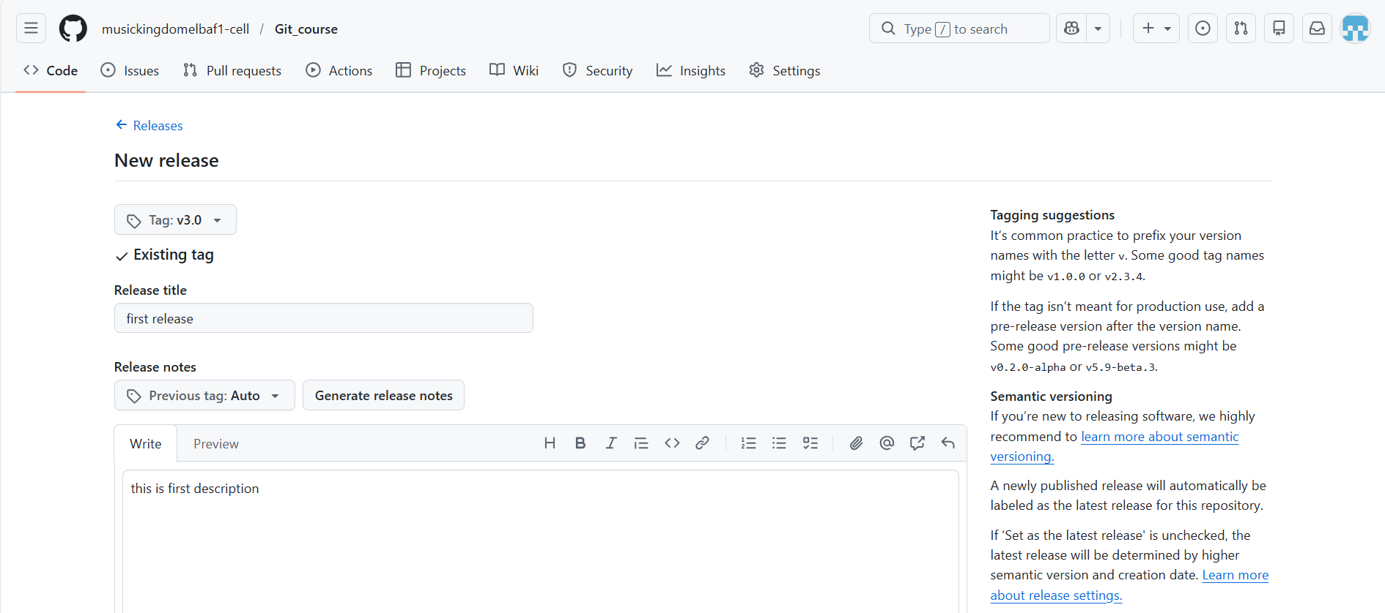
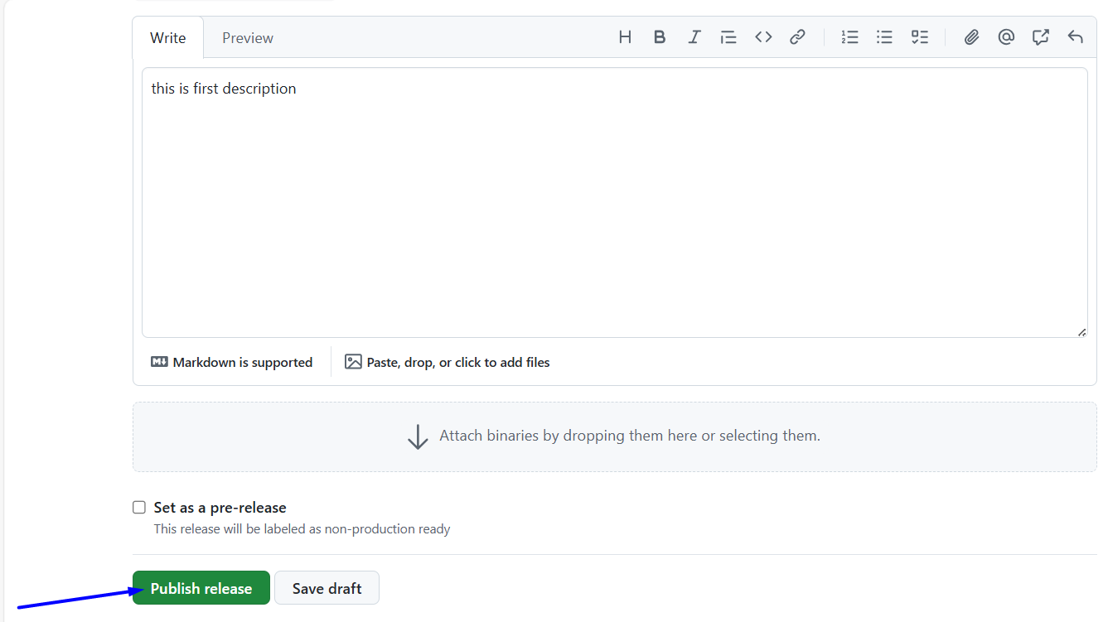
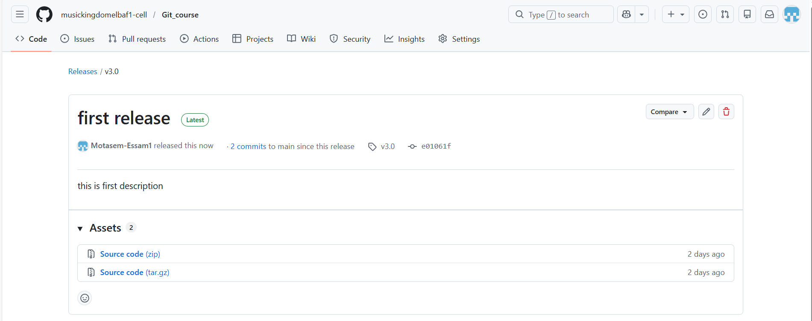

🚀 On GitLab
# Source: ScreenShots Source: Provided by: [Persons Table -> ID Column: 1, Name_En Column: Motasem Essam] -> Tool: [Lightshot Program] -> From [Site: https://gitlab.com] on [2/19/2026]
